**Virtual Assistant**

**About :-**

The motive is to create a personal virtual assistant using python which makes our work simple and easy.

**Index :-**

|  |  |
| --- | --- |
| **S.no** | **Content** |
| 1. | Idea or Introduction |
| 2. | Working Of Our Project |
| 3. | System Requirement |
| 4. | Explanation |
| 5. | Code |
| 6. | Output |
| 7. | References |

**Idea Or Introduction :-**

**-> What is Virtual Assistant ?**

* A virtual assistant, also called AI assistant or digital assistant, is an application program that understands natural language voice commands and completes tasks for the user.
* Such tasks, historically performed by a personal assistant or secretary, include taking dictation, reading text or email messages aloud, looking up phone numbers, scheduling, placing phone calls and reminding the end user about appointments.
* Popular virtual assistants currently include Amazon Alexa, Apple's Siri, Google Assistant and Microsoft's Cortana
* Virtual assistants typically perform simple jobs for end users, such as adding tasks to a calendar; providing information that would normally be searched in a web browser; or controlling and checking the status of smart home devices, including lights, cameras and thermostats.

**-> Uses of Virtual Assistant**

* Social media management.
* Event management.
* Managing calendars, appointments and emails.
* Preparing reports.
* Personal tasks like booking hotels and restaurants.
* Simple digital marketing tasks.

**-> Features Of Virtual Assistant**

* Speech Recognition
* Converts Voice To Text
* Tells Time And Date Whenever We Ask
* Plays Your Desired Song
* Can Tell Humorous Jokes
* Can Extract Information From Wikipedia

**-> Advantages Of Virtual Assistant**

* Time the most important asset of everyone and it save most of it.
* Performs administrative tasks.
* Scalability.
* Increased Productivity.
* Increased Flexibility.
* Reduces Human Work.
* Access to different skills sets

**Working Of our Project**

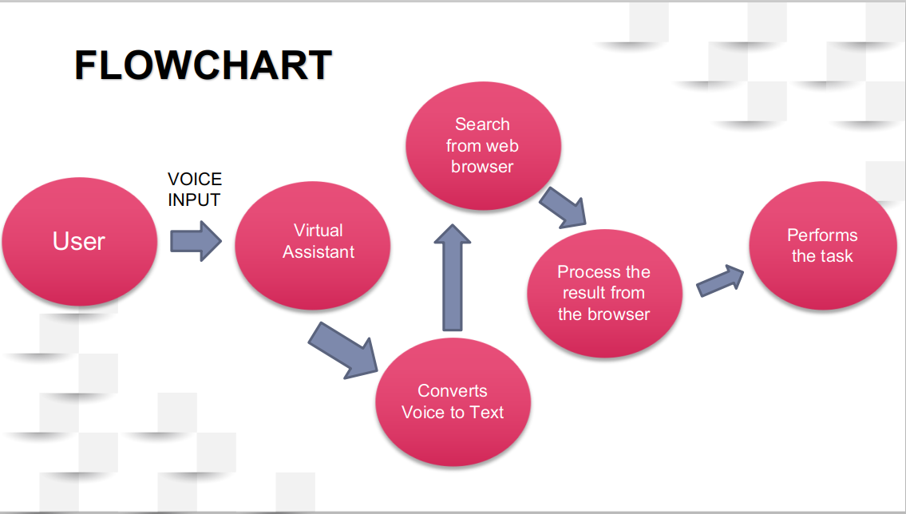

**System Requirement :-**

The following are the hardware and software requirements of our project :-

* A Personal Computer which is in proper working condition.
* We used the stable version of python i.e python 3.7.
* We used the Visual Studio Code IDLE to run our python program.
* We used the following libraries or modules in our project -

1. Speech Recognition (To install the module ‘pip install speechrecognition’)

2. pyttsx3 (To install the module ‘pip install pyttsx3’)

3. pywhatkit (To install the module ‘pip install pywhatkit’)

4. pyjokes (To install the module ‘pip install pyjokes’)

5. datetime (To install the module ‘pip install datetime’)

6. wikipedia (To install the module ‘pip install wikipedia’)

**Explanation Of Code :-**

* We use the import function to import the required modules .The following module which have been imported has the various roles to play.

From the following modules we have 2 most important modules :-

1. Speech Recognition - This module is used to get the voice as the input using microphone.

2. pyttsx3 - This module is used to convert text-to-speech conversion library in Python. It works offline, and is compatible with both Python 2 and 3 version.

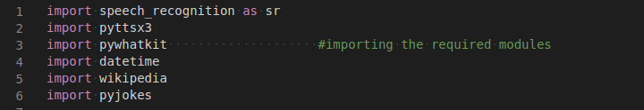

* This part of code is used to take user voice as input and convert it into text format and stores. The other part i.e the ‘getProperty’ part changes the male voice to the female voice
* This part of code is used to take user voice as input and convert it into text format and stores. The other part i.e the ‘getProperty’ part changes the male voice to the female voice

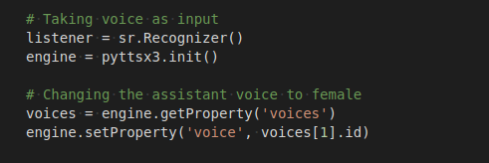

* The ‘talk’ function is used to get the output in audio format and after finishing the task it waits for the next instruction to be given by the user.

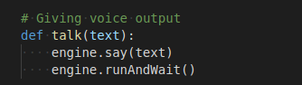

* The ‘take_command’ function is used to initialize the microphone to listen the user voice and convert the voice to text by using the ‘listener’ variable which is declared already for the convertion .

The ‘if’ part is used to make the virtual assistant to get the user voice as input until or unless its name is called (in this case it is “selena”).

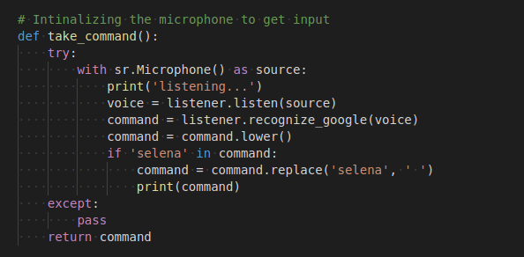

* When user ask the virtual assistant to play the song it recognizes the ‘ play ’ word and goto Youtube , search for the song .

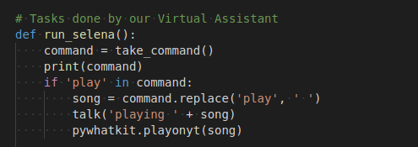

* When user asks the virtual assistant for the time this part of the code recognize the ‘ time ’ word and gets the exact current time and gives the output to the user.

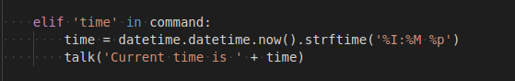

* When user asks the virtual assistant for the date this part of the code recognize the ‘ date ’ word and gets the exact current date and gives the output to the user.

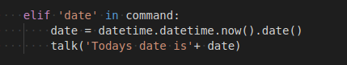

* When user ask the virtual assistant to search about a person (eg. who is Donald Trump) it recognizes the word ‘ who is ’ and search for the information about the person in wikipedia and speaks 2 sentences about him.

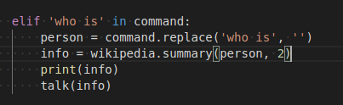

* When user ask the virtual assistant to search about something (eg. what is Global Warming) it recognizes the word ‘ what is ’ and search for the information about the topic in wikipedia and speaks 2 sentences about it .

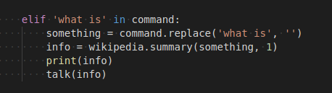

* When user asks for a joke it recognize the word ‘ joke ’ and says a random joke by searching it in the browser.

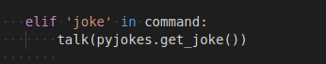

**Total Code :-**

import speech_recognition as sr

import pyttsx3

import pywhatkit

import datetime

import wikipedia

import pyjokes

listener = sr.Recognizer()

engine = pyttsx3.init()

voices = engine.getProperty('voices')

engine.setProperty('voice', voices[1].id)

def talk(text):

engine.say(text)

engine.runAndWait()

def take_command():

try:

with sr.Microphone() as source:

print('listening...')

voice = listener.listen(source)

command = listener.recognize_google(voice)

command = command.lower()

if 'selena' in command:

command = command.replace('selena', ' ')

except:

pass

return command

def run_selena():

command = take_command()

print(command)

if 'play' in command:

song = command.replace('play', ' ')

talk('playing ' + song)

pywhatkit.playonyt(song)

elif 'time' in command:

time = datetime.datetime.now().strftime('%I:%M %p')

print(time)

talk('Current time is ' + time)

elif 'date' in command:

x = datetime.datetime.now()

x = x.strftime("%x")

print(x)

talk('Todays date is'+ x)

elif 'who is' in command:

person = command.replace('who is', '')

info = wikipedia.summary(person,2)

print(info)

talk(info)

elif 'what is' in command:

something = command.replace('what is', '')

info = wikipedia.summary(something, 2)

print(info)

talk(info)

elif 'joke' in command:

joke=pyjokes.get_joke()

print(joke)

talk(joke)

elif 'exit' in command:

exit()

else:

talk('Please say the command again.')

while True:

run_selena()

**Output :-**

* When user ask the virtual assistant to play a song

eg:- “selena play justin bieber”

It opens the youtube and play the song.

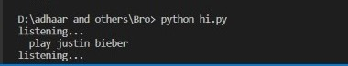

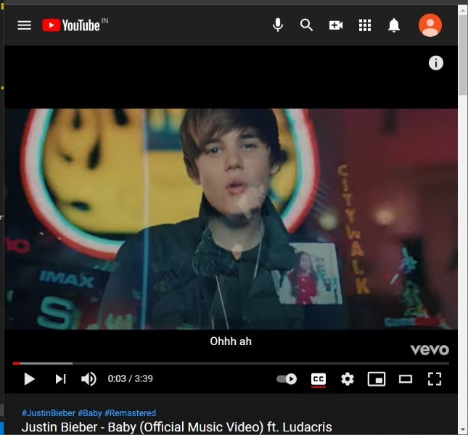

* When user asks the time it gives the audio output and show the current time.

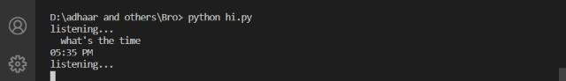

* When user asks for the date it shows and also gives an audio output of it.

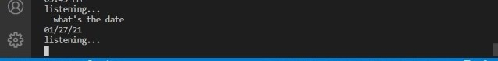

* When user asks the assistant say a joke it goes to the web browser, select a random joke and gives the result in audio format.

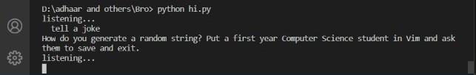

* When user asks for something like “what is pollution” it goes to wikipedia , search about it and says 2 lines about it .

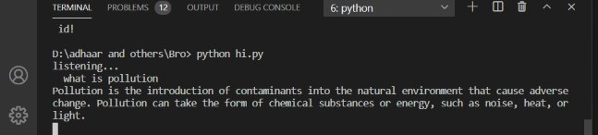

* When user asks about a person like “who is Donald Trump” it goes to wikipedia , search about the person and says 2 lines about him .

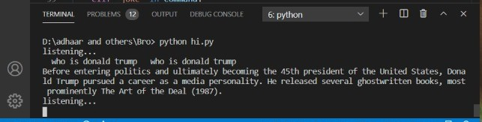

* When we don’t want to use the assistant and the user says exit it stops the program and exit it.

WhatsApp Image 2021-01-27 at 18.03.00 (1)

**Reference :-**

* To download the python modules you can check <https://pypi.org/project/download/>